9th Annual
Mellmer Wrestling
Fall Camp 2018
Open to Middle School and High School Wrestlers
Will have openings for younger wrestlers upon request

Dear Wrestlers and Parents:
We would like to invite you to sign up for the annual fall wrestling camp being put on by Jake and Luke Mellmer. Coaches from various colleges including University of Minnesota, South Dakota State University, North Dakota State University, University of Mary, Minot State University, Minnesota State University Moorhead, and potential others will run each session, Parents and Coaches are welcome to join. Over 70 of the best wrestlers in the state, as well as beginners participated in camp last fall! In past years, Bismarck, Century, Legacy, St. Mary’s, Mandan, Dickinson, Hettinger, New Salem, New Town, Beulah/Hazen, Standing Rock, Carrington, Napoleon, Watford City, and Minot all had wrestlers attend. This camp is for the dedicated wrestler who is looking to get a jump on the upcoming season.
Dates:
September 9, 16, 23, 30 - October 7, 14, 21, 28
- Session Time: 1 – 3 p.m. on Sunday Evenings
- Location – Mandan High School Wrestling Room


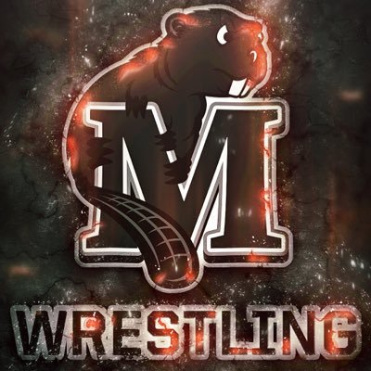

Jake Mellmer
-4 time ND State Champion
-2 time USA Wrestling National All-American
-University of Minnesota letter winner at 133lbs
-Assistant Coach at St. Mary’s High School

Luke Mellmer
-2 time ND State Champion
-3 time USA Wrestling National All American
-University of Minnesota letter winner at 149lbs
-Head Coach at Mandan High School
-ND Class “A” Coach of the Year

REGISTRATION

$150 per wrestler for the eight sessions- Includes RUDIS Joggers

*Checks should be made out to Mellmer Wrestling and mailed to: 915 West Ave. C Bismarck, ND 58501

If you have any questions, please contact:
Jake Mellmer at (701) 260.8576 / jake.mellmer@gmail.com
Luke Mellmer at (701) 260.1041 / lukemellmer@gmail.com.

Mellmer Wrestling Fall Camp 2018 Registration Form

Name: _________________________________________ Address: ________________________________________________
City: _____________________________ State: _______ ZIP: _____________Phone: ____________________

E-mail address: ___________________________________________________

Current Weight______________ High School_____________________________ Grade: (fall ‘18) _______

As a condition of enrollment, the following disclaimer must be signed and dated by the camper’s parent or guardian: The camper, in attending the Mellmer Wrestling Fall Camp and in using any camp facility, does so at his/her own risk. The staff shall not be liable for any damage arising from personal injury sustained by the camper during the camp at the facilities. The camper and his parents assume full responsibility for any damages or injuries that may occur during the camp session and so hereby fully and forever discharge the Mellmer Wrestling Camp, its counselors, employees, and agents, from any and all claims, demands, damages, right of action or cause of action, present or future, whether the same be known, anticipated, or unanticipated, resulting from or arising out of the camper’s participation in the camp session and in the use of the facilities. I/We the undersigned hereby authorize any first aid, medication, medical treatment, medical treatment or surgery deemed necessary for my son or daughter, a participant in Mellmer Wrestling Camp. I/We understand that I/We will be responsible for any expenses incurred on his/her behalf in connection with such treatment. I certify that to the best of my/our knowledge, my son or daughter is in good physical condition and has no disease or injury that would impair his/her performance in training or competition.

I/We hereby consent to the participation of my son or daughter, _______________________ in the Mellmer Wrestling Fall Camp. If he or she fails to obey the camp rules, the director has the authority to expel him/her from camp.
Insurance Company and Policy Number __________________________________________

Emergency Phone Numbers____________________________________________________

Parent/Guardian Signature and Date_____________________________________________

***Send registrations in as soon as possible so clothing can be delivered on time!***

ME11MER WRESTLING RUDIS Joggers

SIZE

- SMALL

- MEDIUM

- LARGE

- X- LARGE

- XX- LARGE

- XXX- LARGE

COLOR

- BLACK/WHITE LETTERS

- GRAY/WHITE LETTERS

